CODING CHALLENGE REPORT

Smart Handwritten Digit Recognition Model

ALEESHA S BOBY
B.Tech in CSE ,CUSAT

Title: Develop a Smart Handwritten Digits Recognition Model.

Problem Statement: Handwritten digit recognition is a fundamental challenge in the field of computer vision and machine learning. Variations in handwriting styles, sizes, and orientations make accurate recognition a non-trivial task. The goal of this challenge is to develop a model that can reliably identify digits (0–9) from handwritten samples provided by participants.
Description of Challenge: Participants are required to create a machine learning model capable of recognizing handwritten digits with high accuracy. Each participant will contribute a small dataset of handwritten digit images, which will collectively form a larger dataset for model training and testing. The challenge encourages participants to explore data preprocessing, feature extraction, model selection, and evaluation techniques. The final model will be evaluated based on its accuracy, robustness, and efficiency in predicting digits from unseen handwritten samples.

TOOLS AND TECHNOLOGIES

Component | Description
Programming Language | Python
Development Platform | Google Colab
Libraries Used | OpenCV, NumPy, Pandas, scikit-learn, scikit-image, Matplotlib
Model Used | Support Vector Machine (SVM) with RBF Kernel
Feature Extraction | Histogram of Oriented Gradients (HOG)
Dataset Storage | Google Drive

DATASET DESCRIPTION

- Total images: around 1000 (10 digits × ~100 images each)
- Each image represents a digit from 0–9.
- Organizes the images into 10 separate folders and was saved into a single folder “Dataset”
- Images were collected and preprocessed.
Data Split Ratio:
- 70% used for training
- 30% used for testing

METHODOLOGY

Step 1 – Accessing Dataset from Google Drive
- The dataset containing handwritten digit images (folders 0–9) was stored in Google Drive.
- The Drive was mounted in Google Colab
- After mounting, the dataset path was defined as “data_dir”.
- This helps to read images directly from Drive, avoiding repeated uploads and ensuring all files were accessible for preprocessing and training.
Step 2: Preprocessing
- All images were converted to grayscale using OpenCV.
- Each image was resized to 28×28 pixels for uniformity.
- Pixel values were normalized (img = img / 255.0) to reduce intensity variations.
Step 3: Feature Extraction (HOG)
- HOG (Histogram of Oriented Gradients) features were extracted from each image.
- HOG is used to captures shape and edge information of each image, making it ideal for recognizing handwritten digits.
- HOG converts the raw image into a compact numerical representation emphasizing edge direction and structure — essential for recognizing different handwriting styles.

Step 4: Model Training

-The extracted HOG features were used to train a Support Vector Machine (SVM) classifier.

-An RBF kernel was chosen for non-linear separation of digits.

-The dataset was split into 70% training(688 images) and 30% testing(296 images).
-The extracted features were used to train an SVM classifier.
-GridSearchCV was used to tune the parameters (C, gamma, kernel) for better performance. It helped to know which C,gamma values were suitedt for more accuracy of the model.
-Best parameters obtained were:
{'C': 10, 'gamma': 0.1, 'kernel': 'rbf'}

RESULTS
The trained model was evaluated using:
  - Confusion Matrix (actual vs predicted digits)
  - Accuracy
  - Precision, Recall, and F1-Score for each digit.

The model achieved an accuracy of approximately 62%.

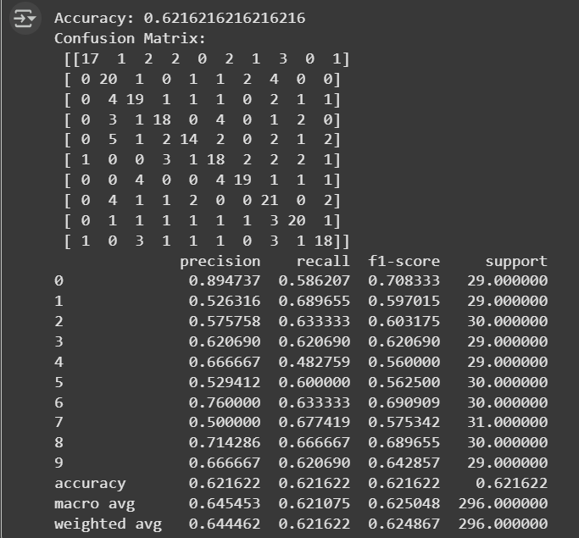

Saving and Loading the Model using Joblib
- After successful training, the trained SVM model was saved using the joblib library so that it can be reused later without retraining.
- This makes the system faster to deploy and easier to test on new user-provided images.
- The model file svm_digit_model.pkl stores all the learned parameters of the SVM classifier.
- When a new image is uploaded, the system loads this file, extracts features from the image, and directly predicts the corresponding digit without needing to retrain the model.

PERFOMANCE TABLE

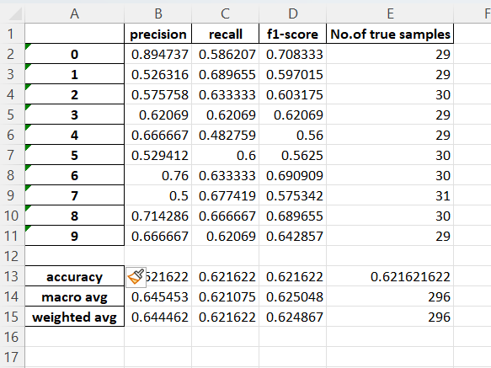

MODEL OUTPUT
Testing with New User Input Images
After training and saving the model, the system was tested with new handwritten digit images that were not part of the training dataset.
For this I asked my friends to write some digits and that was uploaded in my drive as a new folder “Digit_test”.

I used two ways to test the model :
A. Predicting a Single Image
- The user can upload any image in Google Drive.
- The image is then:
  - Accessed in Colab,Converted to grayscale
  - Resized to 28×28 pixels
  - Processed using the same HOG feature extraction as during training
Input image:
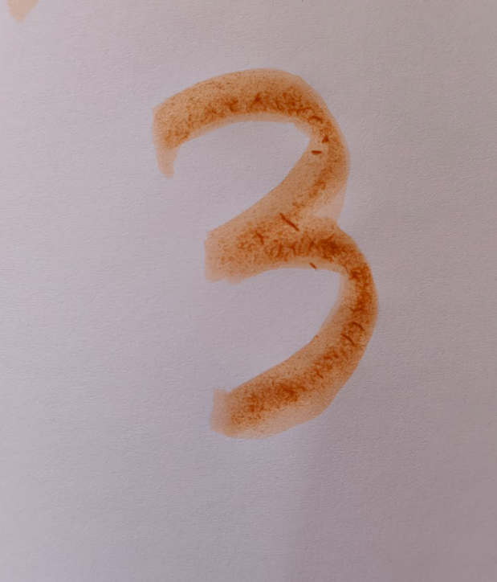
Predicted value:
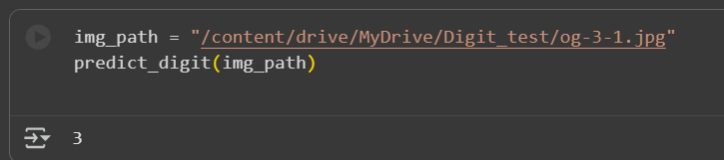

B. Predicting a Folder of Images
- The system also supports batch prediction for multiple images stored in a single folder “Digit_test”.
- Each image is read, preprocessed, and classified automatically.
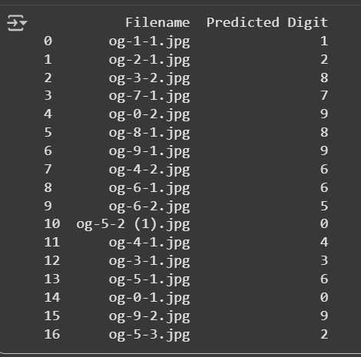
The filename was given in the format : og-“original value of image”-“copy value(random number)”

REMARK->
From the confusion matrix, it was observed that digits 3, 8, 9, and 5 had higher misclassification rates.
These digits share similar rounded shapes and overlapping edge orientations, which made them harder for the SVM model to distinguish using HOG features.
-This ways verified the ability of the model to generalize and recognize unseen handwriting styles.

Observations
-During the first test ,with the usage of : clf = SVC(kernel='linear', C=1.0), the accuracy of the model was only around 48%.
-Some changes were made to increase the accuracy of the model by using GridsearchCV ,which search for the suitable values for C,gamma and kernel.
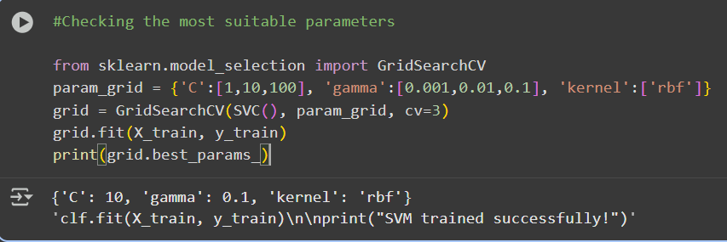
Remark->
When data augmentation was used to multiply the image count so the model can train and test on more data , the Accuracy reduced to 59%. So augmentation is not used in this model.
Final:
-During the testing phase, the model performed well in recognizing most digits, achieving an overall accuracy of approximately 62% on unseen data.
Digits such as 0, 1,2,7 and 9 were recognized with high precision, showing that the model effectively captured distinct edge and contour patterns for these digits.
However, digits 3, 4,5 were more challenging to predict correctly. These digits share similar curved structures and overlapping edge orientations, which sometimes led to misclassifications.
The confusion matrix revealed that most prediction errors occurred between visually similar digits, such as:
- 3 ↔ 8
- 4 ↔ 9
- 5 ↔ 6
Overall, the SVM classifier demonstrated a solid ability to generalize despite being trained on a relatively small dataset.
- The system successfully predicted both single-user images and multiple images from a folder, proving its versatility and real-world usability.

Future Scope
The current system utilizes traditional machine learning methods, which achieved moderate accuracy given the dataset size and handwriting variations.
Future improvements can focus on the following:
- Deep Learning Models: Implementing a Convolutional Neural Network (CNN) to automatically learn more complex patterns and improve accuracy beyond 95%.
- Larger Dataset: Training with more diverse handwriting samples to enhance generalization.
- GUI Interface: Building a simple desktop or web-based interface for real-time digit recognition.
- Noise Reduction and Segmentation: Improving preprocessing to handle noisy or overlapping handwritten inputs.
- Integration with Mobile Applications: Deploying the model for mobile handwriting input systems or document digitization.
These enhancements can transform the current prototype into a highly reliable, real-world recognition system.

CONCLUSION
The project successfully demonstrates a complete handwritten digit recognition system using traditional machine learning techniques.
The implemented HOG + SVM pipeline efficiently extracted visual features and classified digits with a testing accuracy of approximately 62%.
The model performed strongly for clearly structured digits and moderately for those with complex curves or handwriting variations.
All required deliverables — confusion matrix, performance table, and Excel output — were generated successfully. The trained model was also saved and reloaded using Joblib, ensuring easy reuse for further predictions.
Overall, this project validates the capability of classical machine learning algorithms in computer vision tasks and lays the foundation for future exploration using deep learning for even higher accuracy and robustness.

